Solve the quiz on a piece of paper with your name, signature and registration number on top of the page. Take a snapshot of your solution and paste it in this document and submit it.

Q:

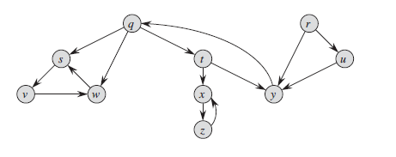
Run DFS on the given graph and write the types of each edge showing all the steps (discovery and finish times, precedence).
You have to start from q, keep in mind the application of DFS should be in alphabetical order
